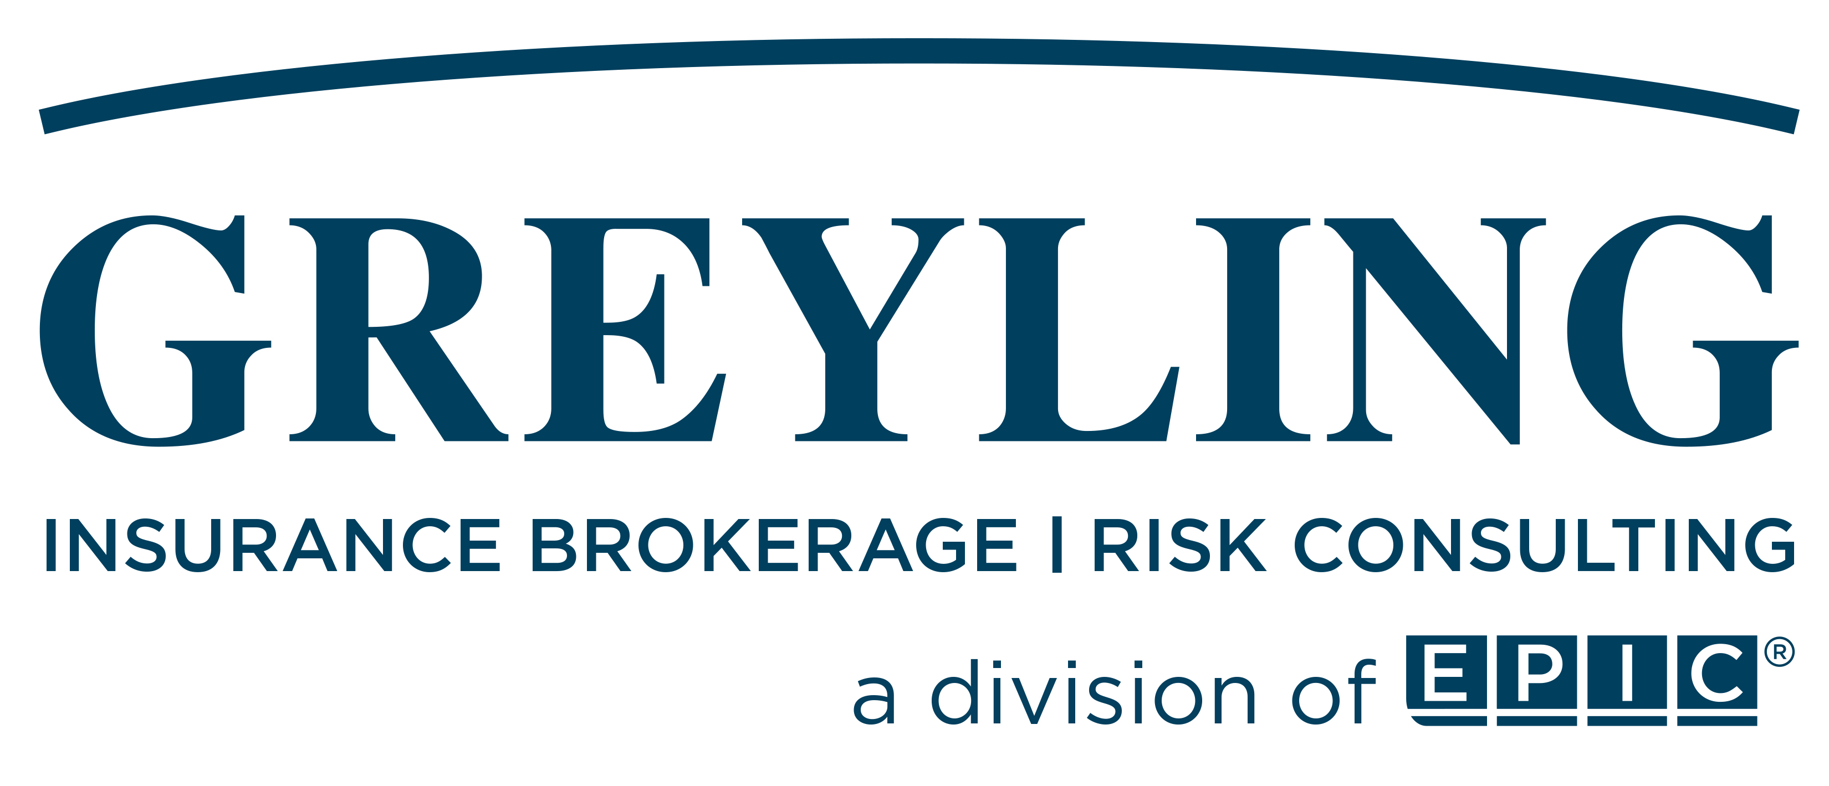

CRB Group, Inc.
Insurance Pre-Renewal

Policy Period:
04/01/2023 - 04/01/2024

Account Executive: zzz
Broker: zzz
Meeting Date: zz/zz/zzzz
Client Executive: Cooper Smith
Senior Client Advisors: Gregg Bundschuh & Bob Staed
Meeting Date: 12/8/2022
Table of Contents
- Year in Review 3
- Program Review 4
- Exposure Information Table 5
- Claims 6
- Exposure Review Questionnaire 7
- Renewal Strategies 10
- Renewal Information 11
- Renewal Timeline 12

Year in Review

- Prior Year’s Renewal
  - Overall Rate Change from Previous Year: (-2.8%)
  - Market Approach: Option 3 (Market) for Cyber & CPPI and Option 2 (Hybrid) for all others
- Products Liability Discussion
- Certificates of Insurance
  - Service Commitment
  - Renewal Certificates
    - List to clean-up sent at least 60 days prior to renewal
    - Due back at least 30 days prior to renewal
    - Certificates sent to clients as soon as possible after binding, but always before expiration
  - Certificate Delivery (e-mail vs regular mail)

Program Review

- Review of program chart
  - Insurers
  - Limits of Liability
  - Deductibles
  - Structure of the program
  - Changes
- Other coverages available
  - Aircraft Liability (Drones)
  - Watercraft

Exposure Information Table

Policy Type | Description | Expiring
Contractor’s Protective  Professional Indemnity and  Liability: | Gross Professional Revenue - Engineers | $231,418,930
Workers Compensation: | Payroll – AOS & CA | $210,337,035
Business Automobile: | Number of Vehicles | 60
General Liability: | Payroll | $142,501,525
Umbrella Liability: | Number of Autos | 60
 | Subcontractor Costs | $522,625,130
 | GL Payroll | $142,501,525
Property & Inland Marine: | Building | $0
 | Betterments & Improvements | $0
 | Business Personal Property | $11,075,000
 | Business Income/EE | $9,910,000
 | Jobsite Trailers | $1,879,000
Foreign Package: | Property Values | $450,000
 | # of Rentals | 80
 | Foreign Revenues | $17,353,687
 | Number of Trips | 200
 | Foreign Payroll | $0
Executive Liability: | Employee Count | 1,612
 | Gross Revenue | $1,034,033,054
 | Plan Assets | $179,175,275
Commercial Crime: | Gross Revenue | $1,034,033,054
 | Employee Count | 1612
Network & Privacy Liability: | Projected Revenue | $1,300,000,000
Kidnap & Ransom: | Employee Count | 1,612

Claims

- Reported Claims from 04/01/2022 to present:
  - 2022-09-01 Builders Risk Civica Ruptured Pipe
  - 2022-09-26 Professional Liability Platinum Performance
  - 2022-11-30 Stemcell Technologies
  - 2022-12-01 Professional Liability BioNTech
  - 2022-12-06 Avid Myford South
- Claim Reporting
  - Report all directly to Greyling except workers compensation and auto
  - The following policies contain claims-made/loss discovered coverage triggers:
- Professional and Pollution Liability
- Employee Benefits Liability
- Executive Risk (Directors & Officers, Employment Practices, Fiduciary Liability)
- Cyber Liability
If you become aware that CRB Group, Inc. is facing a claim or circumstance (potential Claim) arising from or in any way related to the business risks covered under the above referenced policies, your firm has an obligation to report the matter to the respective insurer(s) on a timely basis.
While the timing of when we report Claims or circumstances is always important, we must report all known matters to our insurers before the policy renews on 04/01/2023. Failure to report a Claim or circumstance on a timely basis could result in coverage disputes with insurers.
For specific details, please refer to conditions and definitions listed on the policies.
- Loss Ratio Analysis (See separate exhibit)

In the event of a claim emergency after normal business hours, please call the Greyling 24 hour claim reporting hotline at (770) 552-4245.

Exposure Review Questionnaire

Exposure Review Questionnaire | Yes | No
Professional Liability
- Does (or will) your firm offer any new professional services not provided last year?
- Are there any new or contemplated joint ventures or other co-ventures?
- Does your firm provide “non-traditional” services?
- Ex. Municipal Advisory Services
- Has your firm ever done design work for a product?
- Have you taken an equity interest in any projects or in land connected to any project?
- Does your firm use unlicensed or pirated software?
Property Insurance
- Does the information provided for insurable property values reflect “replacement cost”?
- Do you have equipment in excess of $1,000 that is used in the field?
- Does your firm ship models or other property with values in excess of $10,000?
- Does your firm have any locations in hurricane, earthquake or flood prone areas?
- Is your firm’s equipment used over or under water?
- Do you have a triple net lease at any of your locations? (A triple net lease typically requires you to insure and pay for taxes and utilities of a building.)
- Do you have any underground or aboveground storage tanks on any of your properties that contain any potentially hazardous materials?
General Liability
- Have any significant new operations or services been started during the past year?
- Does your firm lead design-build or CM At-Risk projects or perform any construction?
- Does your firm perform maintenance (directly or via subcontractors)?
- Does your firm perform any invasive testing such as drilling or removing pipe sections?
- Does your firm ever take responsibility for site safety?
- Does your firm participate in joint ventures with contractors?
Workers Compensation
- Are any employees working in ND, OH, WA or WY?
- Do any employees work in a state not listed in item 3.A of the declarations page?
(AR AZ CO CA CT FL GA IA IL IN KS MA MD ME MI MN MO MT NC NE NH NJ NY OK PA TN TX UT VA WI)
- Do any employees work “on or about” navigable waterways?
- Do any employees spend more than 30% of their time working on watercraft?
- Are you licensed in the state of VA? If so, how many active employees work in VA?
Business Auto
- If your firm owns or leases vehicles, has the “cost new” been provided for each vehicle?
- Does your firm own or lease any autos not covered on the business auto policy?
- Does your firm own any vehicles with special equipment?
Exposure Review Questionnaire | Yes | No
Crime/ Employee Theft
- Does cash in the bank exceed crime limits purchased? ($3,000,000)
Executive Risk
- Does your Board currently include or have plans to include any de facto or shadow directors?
- Is your firm currently engaged in or considering any merger, acquisition or divestiture?
- Does your firm anticipate any substantial changes to business strategy over the next 12-18 months?
- Does your firm have any plans to begin or to expand international operations outside of its current footprint?
- Does your firm foresee any significant changes to the size / geographic footprint of its employee count?
- Does your firm have any partners or shareholders of any insured organization who meet the definition of an Executive that the company does not wish to be covered by this policy?
International
- Does your firm have employees working on long-term assignments or permanent locations outside the United States?
- Does your firm perform any work for the U.S. federal government outside the United States that may require Defense Base Act coverage for employees?
- Is your firm in compliance with the Office of Foreign Assets Control (OFAC)?
- Are any of the employees of your firm working in high-risk countries such as Afghanistan or Iraq?
Watercraft
- Does your firm ever rent, lease, or operate watercraft over 26 feet in length?
- Does your firm own any watercraft?
- If yes, is the watercraft ever used for entertaining or recreational purposes?
Aircraft
- Does your firm ever rent, lease, or operate aircraft?
- Do any of your firm’s employees fly a personal aircraft to or from business meetings?
- Does your firm own any aircraft?
- If yes, is the aircraft used for entertaining or recreational purposes or leased to others?
- Does your firm use unmanned aerial vehicles (UAVs or Drones)?

Exposure Review Questionnaire | Yes | No
Other
- Does your firm own or operate any recreational vehicles?
- Does your firm have a corporate apartment?
- Does your firm provide services for secure or proprietary facilities where theft or loss of the plans or other information could result in significant liability?
- Has your firm developed any software products that are sold to third parties as a “product,” i.e., shrink-wrapped software?
- Has your firm published or is it planning to publish a book?
- Does your firm host an electronic chatroom for clients, design or manage Web sites for third parties, or provide services that could damage electronic data of third parties?
- Do you use equipment valued at more than $1,000 offsite?
- List types of equipment, ex. 3D laser scanner; snooper trucks; leased equipment; infrared camera, nuclear density gauge
- Is any of the equipment permanently or temporarily attached to vehicles
- Do you use social media?

Renewal Strategies

Factors to Consider
  - Length and quality of the insurer relationship
  - Satisfaction with insurer services
  - Number of years since last marketing (option 3 below)
  - Need for program changes not suitable to current insurer
  - Changes in staff, financial condition, or underwriting appetite of insurer
  - Loss history (ten years)
  - Notable changes in exposure (new services, acquisitions, or revenue changes)
  - Status of your risk management efforts
  - Insurance marketplace – What is Greyling seeing from other renewals?
Strategy
 | Option 1: Incumbent | Option 2: Hybrid | Option 3: Market
Description | Negotiate only with the existing insurer to develop a renewal program | Negotiate early with the existing insurer based on agreed benchmarks; if benchmarks are not met go to option 3 | Approach the existing insurer and competing insurers for renewal proposals
Recommended Frequency | Applicable to most renewals if insurance program is competitive and insurer is providing good service. | Should be used as an alternative approach between options 1 and 3 if needed to maintain competition but insured is not likely to change insurers. | Once every three to five years.

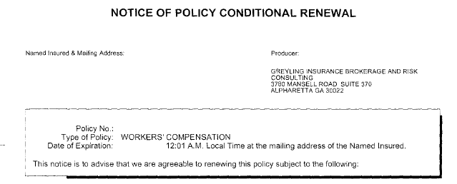
Item to Note: Insurer Non-Renewal Notices

Renewal Information

Coverage | Information Needed | Received?
Professional Liability | - Application  - International Revenue by Office  - Gross Billings  - Largest Projects
General Liability | - Estimated Gross Sales | Received
Workers’ Compensation | - Estimated Annual Payroll | Received
Commercial Auto | - Vehicle Information  - Driver List  - Annual Cost of Hire | Received
Property & Inland Marine | - Building Value(s)  - Business Personal Property Values  - Business Income Values  - Equipment Schedule
Executive Risk | - Application  - Board of Directors List
Foreign Package | - Application  - CRB International SOV  - International Travel List
Kidnap & Extortion | - Application
Cyber Liability | - Application  - Ransomware Supplemental
General Information | - Named Insured  - Financial Statements

Renewal Timeline

Insured: | CRB Group, Inc.
Renewal date: | April 1, 2023 (Saturday)
Coverage(s) renewing: | All Lines of Coverage
Activity | Who | No. of Days Prior to Renewal | Due Date
Request updated renewal information and applications | Greyling | 115 | December 7, 2022 (Wednesday)
Pre-renewal strategy meeting | Greyling/CRB Group, Inc. | 114 | December 8, 2022 (Thursday)
Provide updated renewal information | CRB Group, Inc. | 82 | January 9, 2023 (Monday)
Prepare renewal submission/send to underwriters | Greyling | 75 | January 16, 2023 (Monday)
Meet with underwriters | Greyling | 54 | February 6, 2023 (Monday)
Deadline for renewal quotations | Insurers | 44 | February 16, 2023 (Thursday)
Complete coverage and program design negotiations | Greyling | 36 | February 24, 2023 (Friday)
Present final renewal options | Greyling/CRB Group, Inc. | 33 | February 27, 2023 (Monday)
Select insurer and bind coverage | Greyling/CRB Group, Inc. | 31 | March 1, 2023 (Wednesday)
Estimated Issuance of Issue certificates of insurance | Greyling | 24 | March 8, 2023 (Wednesday)

Greyling Insurance Brokerage | A Division of EPIC
Client Service Team for CRB Group, Inc.
Team Member |  | Role |  | Contact Information
 | Gregg Bundschuh, JD  Co-Founder & Managing Principal | Senior Client Advisor  (advises on overall strategy and assists with special projects) |  | Office Phone: (770) 220-7697  Cell Phone: (770) 330-9747  E-Mail: Gregg.Bundschuh@greyling.com
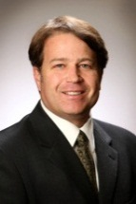 | Bob Staed, JD  Managing Principal | Senior Client Advisor  (advises on overall strategy and assists with special projects) |  | Office Phone: (770) 670-5328  Cell Phone: (314) 753-2032  E-Mail: Bob.Staed@greyling.com
 | Cooper Smith  CRIS | Client Executive  (main contact with overall account responsibility) |  | Office Phone: (770) 670-5325  Cell Phone: (770) 823-0597  E-Mail: Cooper.Smith@greyling.com
 | Kent Collier, JD, CRIS  LEED AP BD+C | Complex Claims, Contract Review, Risk Management, Back-up Client Executive |  | Office Phone: (770) 220-7692  Cell Phone: (404) 274-4636  E-Mail: Kent.Collier@greyling.com
 | Nick Benson | Account Specialist  (Broker Support | Claims Reporting) |  | Office Phone: (770) 679-7359  E-Mail: Nick.Benson@greyling.com
 | Nicole Larsen | Account Specialist  (Broker Support | Claims Reporting) |  | Office Phone: (770) 220-7686  E-Mail: Nicole.Larsen@greyling.com
 | Carly Underwood | Assistant Manager, Certificates of Insurance |  | Office Phone: (770) 670-5324  E-Mail: Carly.Underwood@greyling.com
 | Erin Maurer, CIC, CRM | Policy Manager  (checks policies, verifies documentation, and develops coverage specifications) |  | Office Phone: (770) 552-4225  E-Mail: Erin.Maurer@greyling.com
 | Winnie Chan | Accounting |  | Office Phone: (770) 670-5353  E-Mail: winnie.chan@greyling.com

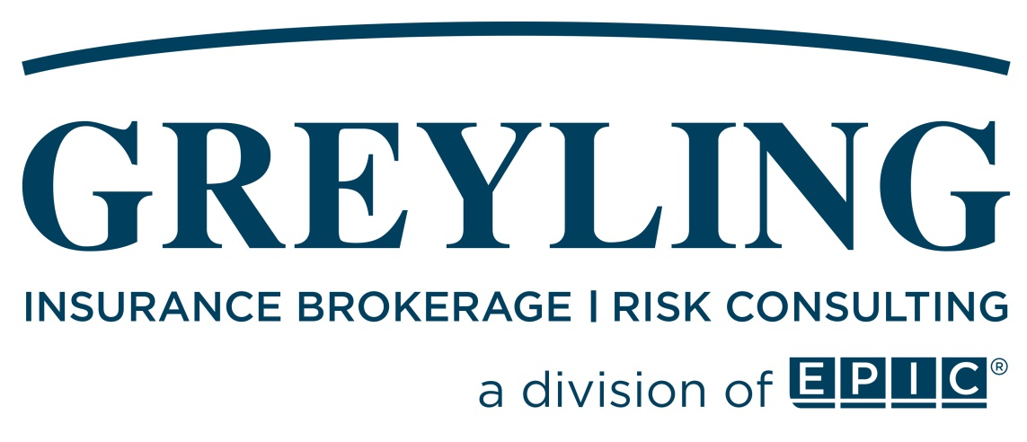

Offices: | Atlanta, Georgia  Portland, Maine  St. Louis, Missouri
Phone: | (770) 552-4225
Fax: | (866) 550-4082
Email: | info@greyling.com

Disclaimer: This report is not a legal contract. The coverage summaries are intended to provide a brief overview of the terms, conditions, limits, and premiums of the insurance coverages described. The information in this report may not be used in adjusting or adjudicating any loss. This report does not grant or bind coverage and is not intended to serve as evidence of coverage in place. It is meant solely to provide you with a brief synopsis. For detailed and accurate information about the coverages provided, you must read the actual policies.
The coverages we have placed for you are based on our understanding of your operations. We rely on you to provide us with the necessary information to provide appropriate policies and coverages. It is your responsibility to advise us of your operations, including any changes, such as (but not limited to) operations in new states, new services provided to your clients, new vehicles or equipment, and new property locations.

